Water Purification and Delivery RO System
Overview
The Pure Water System is in 2 Parts
RO Water Creation into customer IBC tank
DI Water Delivery from Tank to 4 Operators
RO Water Creation
1 - Carbon Filter 120,000 Gallons
3 - RO Membranes High Flow
3 - 12v RO Boost Pumps
3 - Tank Water Level Monitoring Probes Turn off Pumps
3 – Water Level flow valves for Positive Water Stop
Water Delivery– 4 Operators
4 - 1 Gallon per minute Pumps
4 - Pump Controller with Long Range Remote Fobs
4 - DI Filter Housings and 4.5x20 Inserts
4 – Bags of DI Resin
4 – Delivery Reels with 200ft of 3/8 Delivery Hose
The system can run from Tap Water Pressure
When there is 60PSI or over and 5 gpm or more from the tap water input hose it is not necessary to turn on RO Boost Pumps
Depending on Water flow, the operator can select No Boost, 1 RO Boots pump, 2 RO Boost Pumps or with 7 gpm available all three RO Boost pumps
Note:
The system is configured on 4 mounting plates, each plate has two bushings on u-bolts that allow the connection of the plates to the IBC container rails. It is recommended that additional attachments are made to the IBC to securely hold the plates to the IBC for travel
Filter Replacement
Replace the Carbon Filter every Quarter
Replace the DI Resin in the Cartridge when the TDS reading is above 10 TDS
When the TDS starts to creep above 1 or 2 on the TDS meter make sure you have a Resin Bag handy… There is a TDS meter per operator and cartridge
The RO Membrane’s should last 5 to 7 years with the proper replacement of the Carbon filter and the RO Flush ate the beginning and end of each job for 30 seconds or more
Power Requirements
The RO Creation System and the Operator Water Delivery system both have their own Power Requirements and Battery connection Cables (4 Gauge wire) and need separate battery banks
We recommend 4 qty 100-amp batteries for the RO Creation system
And 2 qty 100 Amp batteries for the 4 Operator Delivery System
Note:
We are providing 4-gauge wires to route to the battery packs but are not quoting batteries or attaching of the wiring to those packs

In rush current (for sizing)
3 RO Pumps 22 amps (12v) 66 amps 800 watts
4 Delivery Pumps 6 amps (12v) 24 amps 300 watts

Running Current
3 RO Pumps 16 amps (12v) 48 amps 600 watts
4 Delivery Pumps 4 amps (12v) 16 amps 200 Watts

Battery charger
This would be attached to the 12v batteries
When connected to the battery the in-rush is not an issue as the battery will absorb that
And you don't need to cover all of the current draw as the battery can drain and
charger as you use more or less current
Like: When the tank is full the RO pumps are off and the battery recharges

RO Water creation Pumps we recommend a 75-amp hour charger
Example 1
https://theinverterstore.com/product/aims-ac-converter-battery-charger-12v-24v-smart-charger-75-amps-large-charging-capacity/
Example 2
https://www.ebay.com/itm/394989553595

For the Water delivery Pumps, we recommend a 40amp charger
There is a charger like this that also offers a 200amp manual boost available at Harbor Freight
With the goals of a 75-amp 12v Charger will run the RO Creation from an extension cord
and the 40-amp charger for the Delivery Pumps will do the same
Mounting the plates
We recommend Four People for the task of attaching, as you need to move and hold the Operator Plate and the two Pump Plates together as they are attached to each other with wires and plumbing
Assign one person to each plate (3 Plates) first
Then carry the plates to the IBC
Strat with the operator Plate, Place, “Hang it” from the top bar of the IBC, by setting the u-bolts on the top bar…
and as one person holds it there,
Then next person will “hag” the 3 Pump RO plate on the top bar to the right of the operator plate
and the 3rd plate the delivery plate hangs and them mounts to the middle bar below the 3 Pump RO plate. (person 3) The delivery plate will also have the input water line that will need to be routed to a convenient spot in the trailer
Once they are all in position and being held in place
Person 4 is now tasked with the opening the U-bolts and mount bushing, placing the mounting bushing over the IBC Rail, and putting the u-bolt back around attaching the u-bolt to the mounting bracket on the plate
There is a video instruction for this process.
Now mount the 4th plate (RO Membranes) to the right of the pump plates to the IBC. This will also have the RO Flush valve Trident attached set that on top of the tank for now

The plates all have a U-Bolt bracket on the top to attach each plate to the IBC
The Locations are pre-determined, and the plates will install on three sides of the IBC
The Operator Panel and RO Membrane Panels are meant to be installed on three sides of the IBC container.
The Pump Plate will be mounted on the short side that on the Right Side of the Operator panel
Note:
In our testing we installed the Operator panel and the RO Membranes on the long sides of the IBC Tank. The pump lates were installed on the shorter side, you may want to review your installation to pick the side.
Correct Orientation
The plates are wired and plumbed in such a way that the
The first Plate is operator plate
To the right of the are the two pump plates
RO Plate (3 pumps, carbon filter) above the 4 Delivery Pumps
To the Right of the pumps and opposite the Operator Plate is the RO Mount Plate

RO Flush Valve (from RO Membrane Plate)
Now mount the RO Flush Valve Trident to a spot on the IBC or Trailer Wall where the Operators can easily get to the Valves

RO Permeate to tank (from RO Membrane Plate)
RO Filtered (Permeate out lines) are also routed to the top of the tank to be installed into bulkhead fitting and tank float valve

Input Water Line
The input Water line (attached to the Carbon Filter) can be routed near the back of the trailer.

The RO Pump Lines (from the RO Pump Plate can now also) be connected to the RO Membranes

The Delivery Pump Plate water pickup lines can be routed to the top of the tank

4RO Water Creation

There are two mounting plates,
- One that controls the RO Boost Pumps
The water flow through the Carbon Filter and out the plumbing 8 GPM
- One that hold the RO Membranes

RO Control Plate Layout:
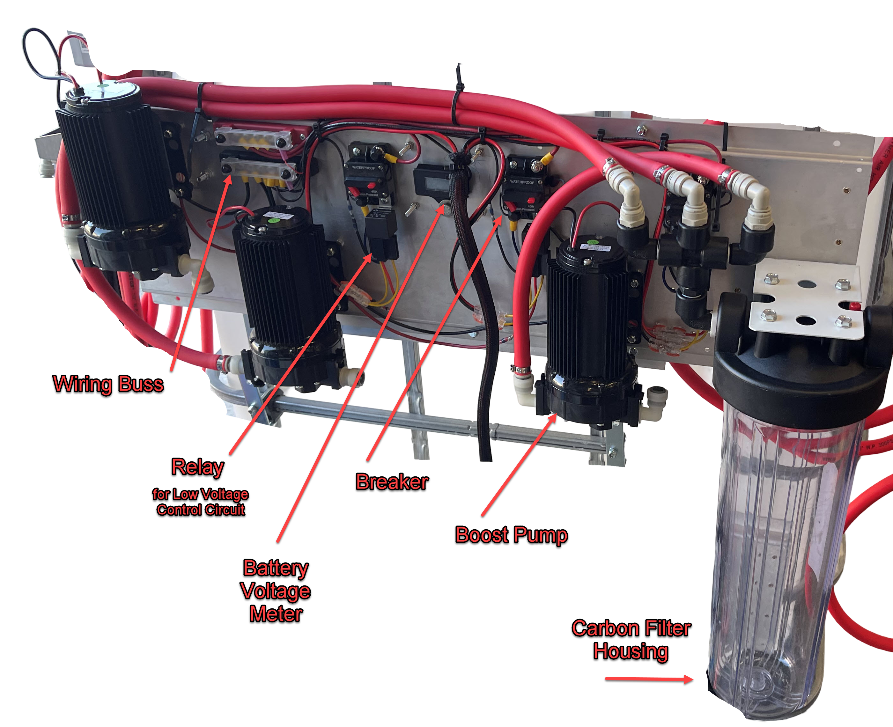
The Power is routed to the power panel via 4-gauge wire from the battery/power source.
There is a breaker for the high Amp Power that each pump uses, and it also powers the low amperage control circuit as well, the low amperage system controls a high-power relay for turning on and off the pump either manually or when the water level rises to the float switch.
The Low amperage control consists of a s a RO On-Off switches (3 each) mounted on the Operator Panel and the tank level sensors (3 one for each pump)
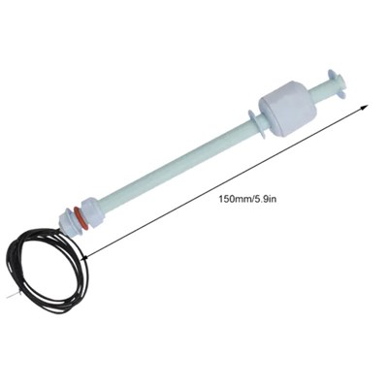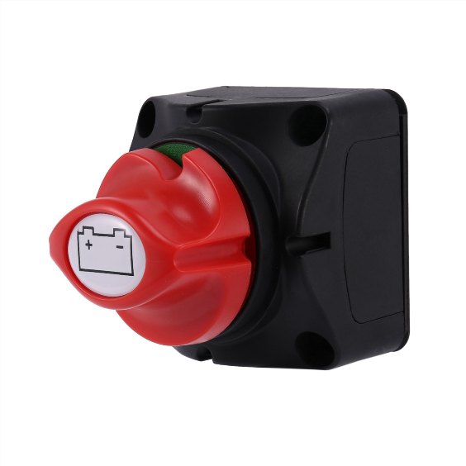
Tank Probe RO Pump On Off Switch
The low amperage circuit runs from the Breaker switched power, through the relay and on to the Tank Probe, then to the RO power switch right back to the relay.
Note: Be careful when installing Install the tank probe to pick a place where you can reach the underside of the hole to insert the Tank Probe wires and body into the hole
The RO pumps will be off when the probe senses the tank is full (and/or) when the RO Switch is off,
Note: the probes will need to be installed into the top of the customer IBC tank and the probe wires attached, in as shipped configuration the water probe sensors are not operative. (see video)
The high amperage current runs from the Battery with a 4-gauge wire to the Buss Bar
Note:
For any of the breaker Switches they are not meant for day-to-day operation, there are the resettable fuses for this system for all 7 of the pumps
The Buss Barr routes power to each of the Breaker Switches
RO Pump Water Creation… The power from the breaker runs though the low amp circuit above which controls the relay to switch the high amp power on and off
Operator Water Delivery … The breakers deliver power to the pump controllers.
Note: The Breakers should be turned off when performing pump replacement or maintenance on the delivery pump controllers.
RO Flush Valves

RO Flush Valves for each membrane are on a mounting bracket for easy positioning
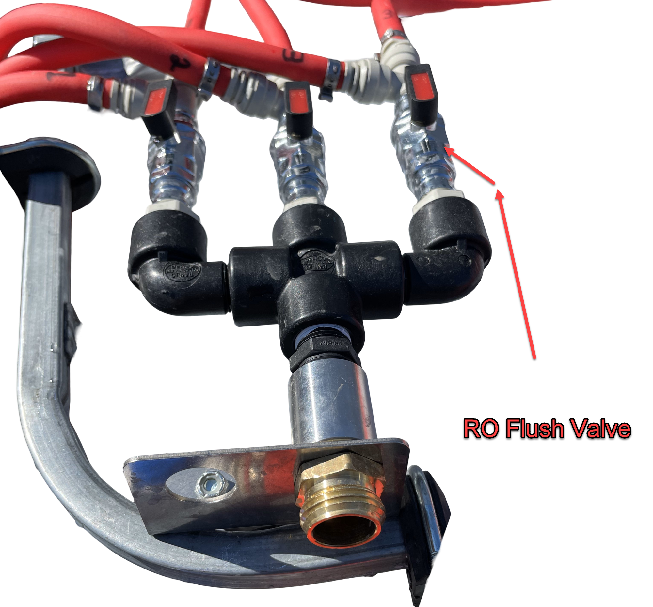
The Flush Vales should be opened at the beginning of the job and allow water to freely flow for about a minute
They are in Flush Mode in the picture above
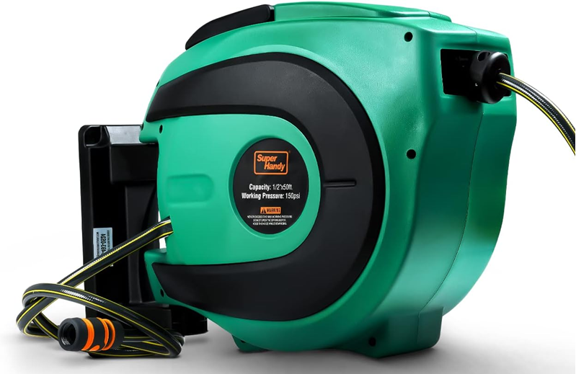
After flushing turn the valve 90 degrees to enter production mode for producing RO water.
Route the flush water out to landscaping
A retractable hose reel could be used to route the flush water out to the landscaping
https://www.amazon.com/SuperHandy-Retractable-Commercial-Industrial-Disconnects/dp/B082TZ9FWF

Th RO Membrane Plate
This plate holds the housing and RO Membranes inside them for the RO purification of the water into the IBC Tank.
Shown here mounted to the IBC Tank
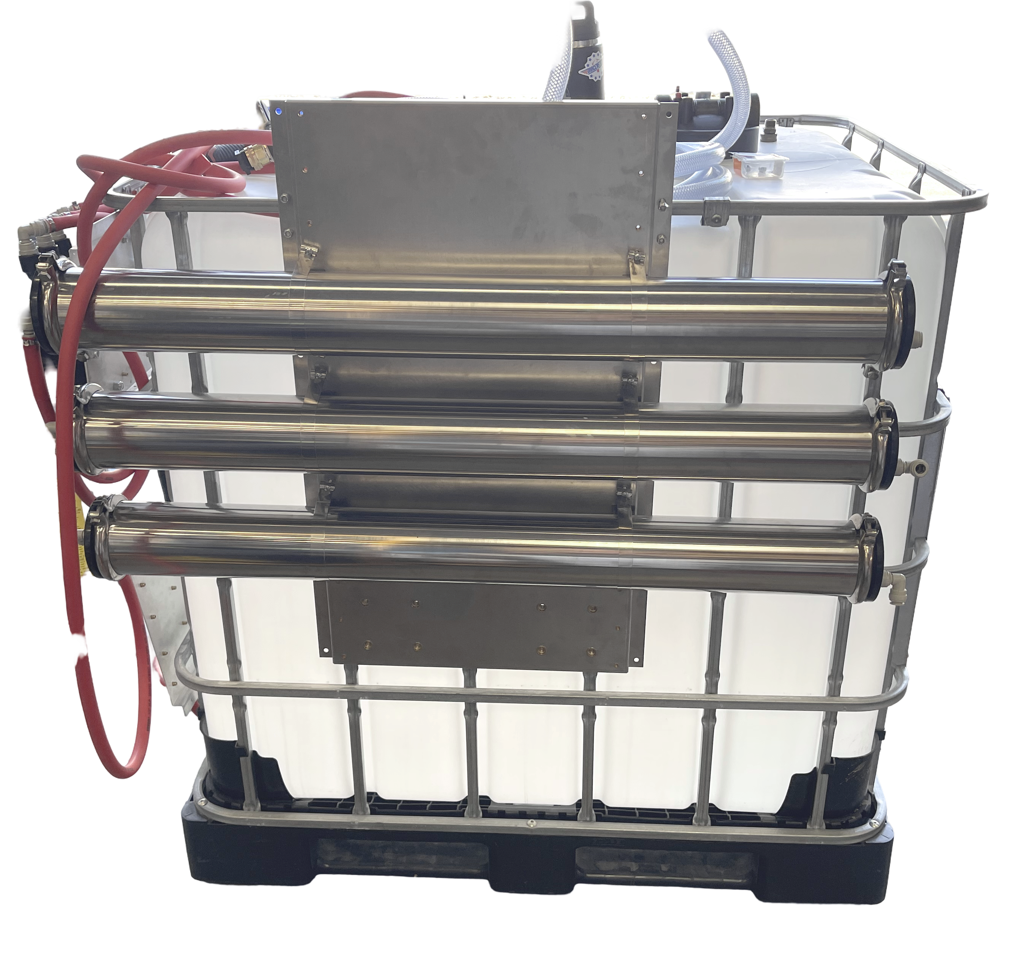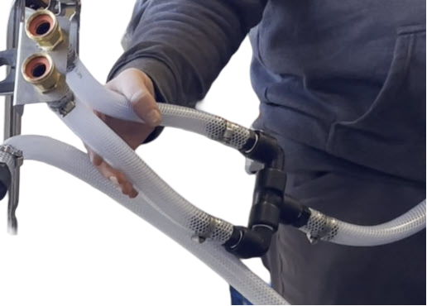
The Water Input line has two inlet hoses in order to get enough water.
The system ideally wants to receive 7 gallons per minute (GPM) at 60 psi
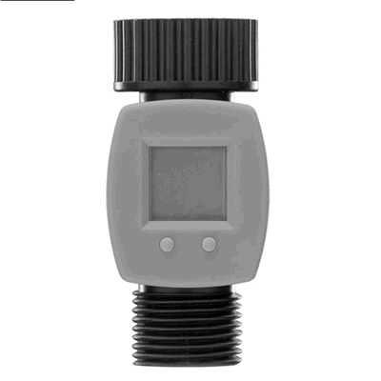
In our shop for instance we have two water sources, one is 4.5 GPM and the other is 6.8 gpm, together these offer enough water flow to run all three ROs membranes and pumps, the system could operate solely on the 6.5 gpm source, and we would recommend turning off the third RO Membrane Pump when doing so.
Not every site will have a single line with 7 GPM available
You should keep a Gallon Per Minute water meter available to test the water flow at each job site.

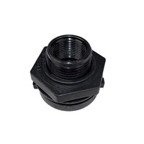
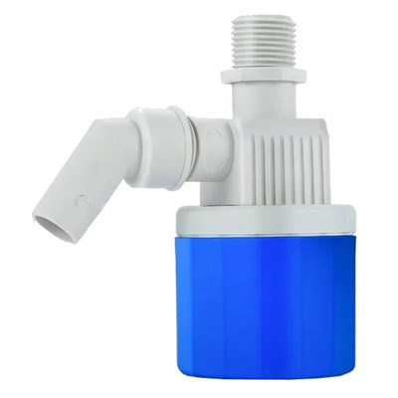
The Output of each of the RO Membranes is routed to a bulkhead fitting with an attached Water Float Valve
Install the 3 vales and fittings onto the top of the IBC Tank
Attach the water lines from the RO Center (permeate) output lines to the Tank Float Valve Bulkhead fitting

Water Delivery – Operator Plate
The Operator Delivery side consists of two plates
The Operator Panel or control station, offers the ability to
Turn on and off the Operator Delivery Pumps (4) to one of the 4 reels
Review the TDS of that operators Water Delivery
Change the DI Resin Cartridge specific to that Operator and TDS Meter
Review RO Membrane Input Water Pressure individually (3 Gauges)
Turn on and off the RO Boost Pumps
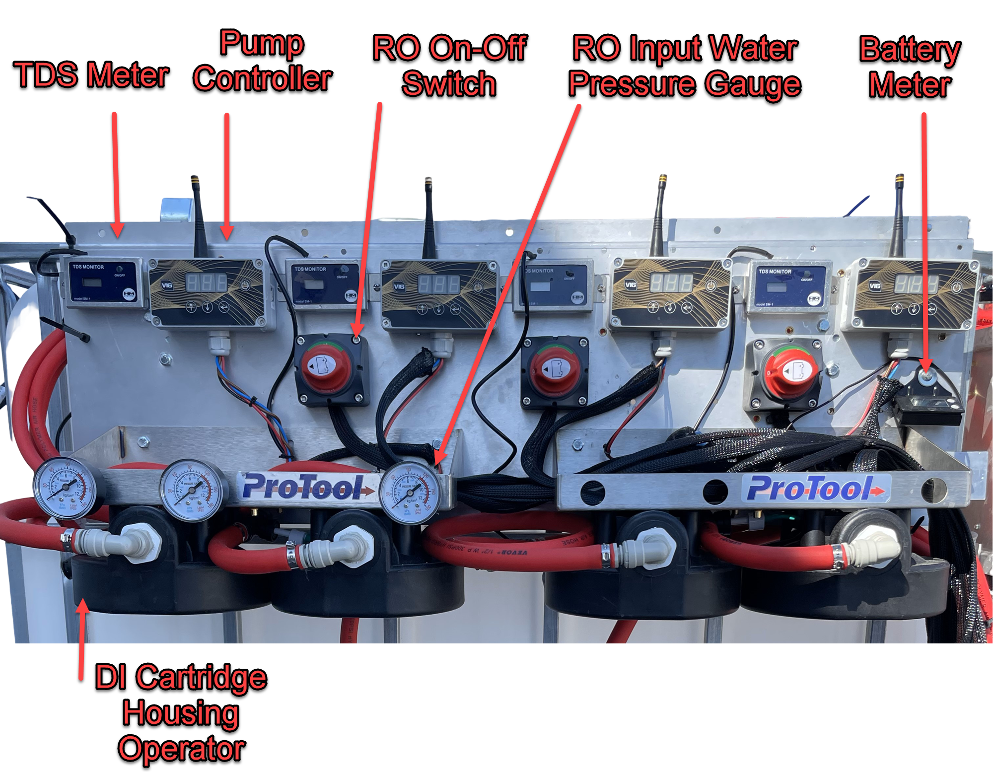

Water Delivery – Pump Plate
The 4 Operator Pumps, Input Power from 4 Gauge Cable and breaker switches are located together on this plate which mounts below the RO Booster Pump Plate
This is connected to the Operator Plate both with wiring and plumbing hoses
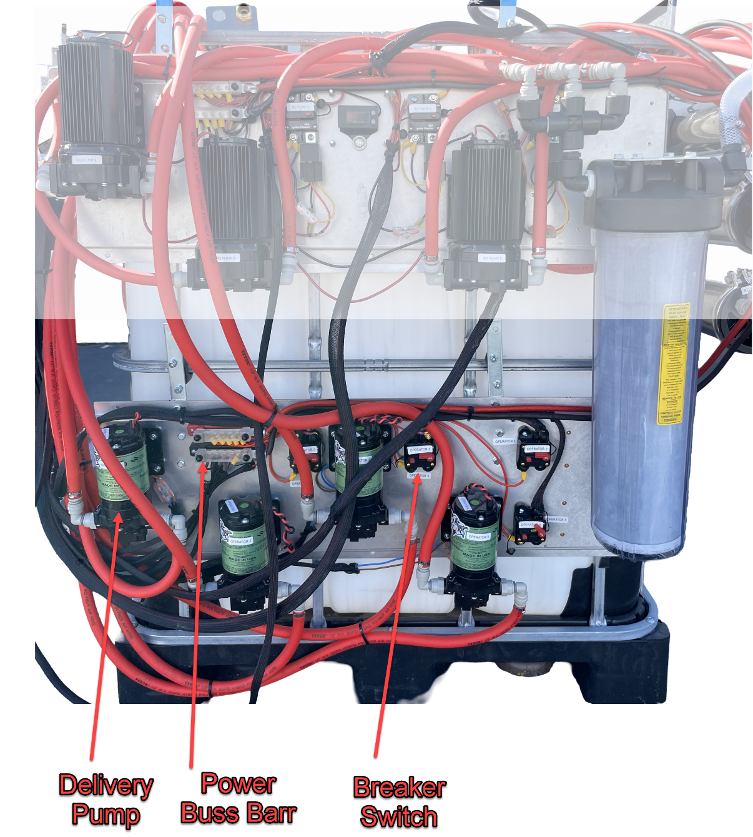
The water lines (hoses) that draw from the tank are connected to the input of each of these pumps,

The inlet lines are attached to bulkhead push fittings.
This fitting will need to be installed into the top of the customer IBC Tank
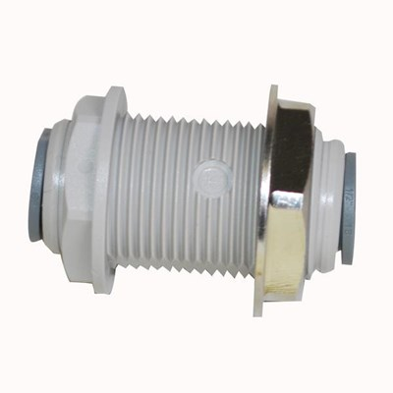

The Operator Delivery Pickup

Installing the Bulkhead Fittings
The Draw Tubes form the pumps will have the Bulkhead fittings on them
Remove each one and install the Bulkhead into the IBC Tank
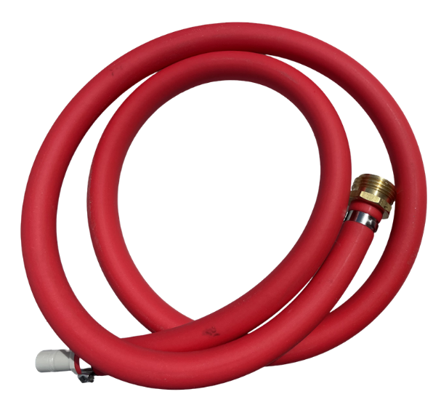
Note the Draw lines are installed from inside the tank into these fittings so install where you can reach the underside of the bulkhead fitting to insert the push-fit connector into the bottom of the bulkhead fitting
The Draw Lines were shipped in a separate box and look like this:

The Male Garden Hose fitting on the end is just used as a weight to keep the end of the draw hose on/near the bottom of the tank.

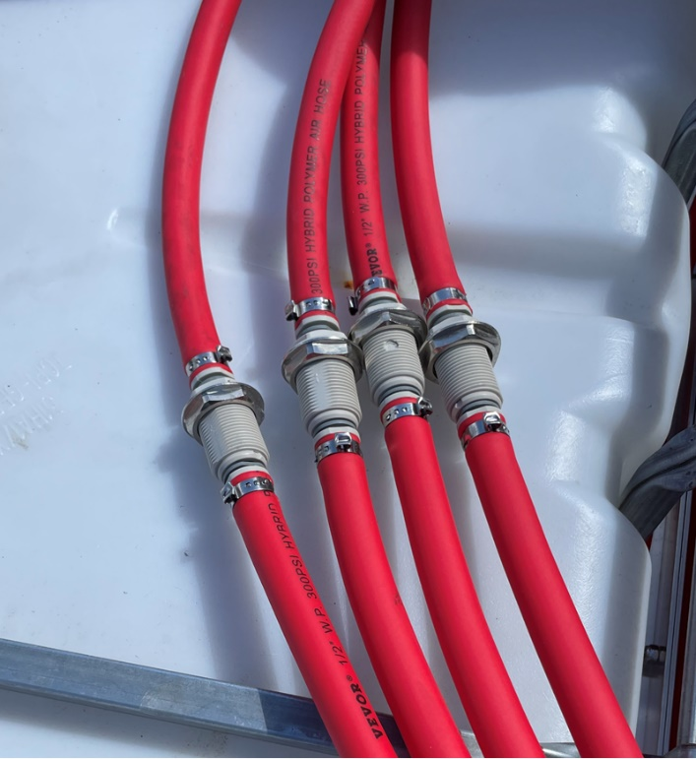
When connected:
The bulkhead would be installed into the top of your IBC first

Comment:
We went with 4 DI housings and drew RO Purified Water from the IBC tank because DI water quickly returns to RO Water when left standing in a tank.
Making DI water into a tank and leaving it in the tank over the weekend and the DI water will be RO Water come Monday.

It is best to treat/polish the RO Water immediately before using it on the glass

Reference Items:
Pump Controller
The pump controller will require calibration and fob pairing
You can find the manuals instructional videos on our website
Enter 150-5452 in the search box
https://www.jracenstein.com/p/pump-controller-v16-wfp-link-long-range-remote-control-15-amp-12v/150-5452
Manual PDFs are on the documents tab, the Instructional Videos are on the man screen

Wire Size
This is a chart that describes wire sizes needs for amperage and run length
The 4-gauge wire is sufficient for the run that the system delivered with.
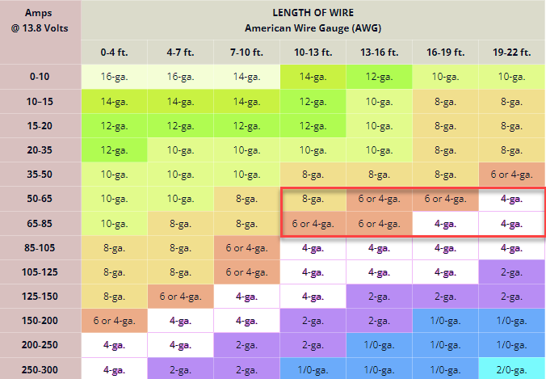

Daily Operator Use

The operator concentrates their attention on the
Water inlet Connection and Water Flush First
Then the Operator Panel

Daily Operator Use
- Arrival on Site
  - Determine the amount of water in GPM and pressure is available
  - Lots of water and pressure (7GPM at 65psi) all is well
If not enough water
  - Is the job big enough to try and source a second spigot?
  - If just one and less than 7 GPM, then only 1 or 2 of the RO pumps will be turned on but that is for later
- Attach the inlet feed water source
- Plug in the Trailer to building power
- Attach the RO Flush hose and place in the landscaping
- Open the Flush Valves (3 Valves) prepare to Flush for a minute while setting up
- Turn on the Feed Water
- Flush for 1 minute
- Tuen the RO Flush Valves into production mode
- Review Water Availability and size of job, # operators
- Review Water Availability and size of job, # operators

  - If you have great water pressure and flow
  - Only going to support 2 operators
You probably don’t need to pump
  - If you need flow for 4 operators and the water is 7 GPM but low pressure, then
Turn on 2 or 3 RO pumps
- Select an operator Number (1 to 4)
  - Find the Remote Fob
  - Open the end of the delivery hose on the Reel
    - Do not attach a pole yet
  - Turn on the controller using the enter button
  - Use the fob to start flow
  - Check the TDS on the TDS meter
  - If less than 10 continue,
    - more than 10 TDs change resin
    - (or select a different operator position)
  - When TDS is low use the fob to turn off the flow and now attach the pole
- Ready to clean

Daily Operator Use
End of Job
- Turn off the pump controller/ fob
- Disconnect the pole
- Roll in the pole hose secure the Reel
- When everyone is done
  - Open the RO Flush Valves (3)
  - Pause a moment (30 second or more)
  - Turn off the feed water from the tap
  - Recall the RO Flus water hose
  - Disconnect the Inlet Feed Water

